Guardians of the Arena

Group H

Joey Shepard - designer, producer, and programmer

Daniel Tenorio - designer, and programmer

Steven Kawafuchi - designer and programmer

Jordan Hua - designer and programmer

Chris German - sound artist- sfx and background music

We plan on using a spreadsheet to divvy up the programming work and communicate who is working on what. Spreadsheet can be found [here](https://docs.google.com/a/uci.edu/spreadsheets/d/1W4T-KTIXXPl_zBg936XmlJFUYLgrR0PrILJ1LyPd0l4/edit?usp=drive_web).

Overview

* + “Guardians of the Arena” is a 1-on-1 turn-based board game with an arena flare and is based in 2D. The board is tile-based, much like chess, and the players battle to eliminate the enemy forces to win. The players can customize their starting lineup, determining which units to use and where they are placed initially on the board. Each turn, the player can move and attack with as many units as his/her resources allow. There will be environmental obstacles, and a unit composition of around 10 distinct units. It would include ranged spellcasters, tanky melee units, and some immobile structures with spells/auras (totems). It would be preferred if the artist could provide visual effects for to accompany the units that need it.
* **Description of game play, key features, win conditions**
  + Player’s must kill the enemy Guardian (robust warrior unit) and then kill the Soulstone in order to win.
  + Players have 1 minute per turn
  + Players have a resource system that allows unit movement and attacks
  + There are two factions to pick units from
  + There will be one neutral faction where either faction can pick units from
* **Genre and important influences**
  + Turn based multiplayer strategy
  + Strongly influenced by Tactics Arena Online, Hearthstone, and Final Fantasy Tactics
* **Art design**
  + TBD
* **Technical platform**
  + Unity 4.3 with C#, Visual Studio 2012 with C#, and Github; We will be releasing the game for PC

How the Game Works

**Mechanics and Player Design:**

**Start Steps-**

1. 1 square grid is chosen.  (1 of 3 randomly picked grid shapes possibly in future)
2. 10 squares on the grid will be randomly chosen as “shrub” objects.
   1. Shrub- a square that indicates that neither player can set their pieces on and impedes movements and attacks.
3. Player 1 and Player 2 set their pieces on the grid.
   1. Both players are given the same number of in-game currency called “unit points”.  Unit points are used to purchase the players’ pieces.
   2. Neither player can or will gain unit points for the rest of the game
   3. Given the selected grid and the 10 randomly chosen squares as shrubs, here is how the player will set their pieces before the game starts:
      1. Player 1 can set their pieces anywhere on the 3 lower-rows of squares, and Player 2 can set their pieces anywhere on the 3 upper-rows of squares.
4. **Player Pieces Setup-**
   1. Player 1 and Player 2 have the choice of picking between 2 factions (Faction A and Faction B) which have different sets of pieces.  Both players can use the same faction if they want. Players using either faction can pick units from the Neutral Units set. ([**Unit Spreadsheet**](https://docs.google.com/a/uci.edu/spreadsheets/d/1aTu4rTUQYx6VsWrD9ubFAJOJuLUy1NCjey2VQVlH4gE/edit#gid=0) for more info on each piece)
   2. **How to read the Unit Design Spreadsheet**
      1. **Unit Name-**

Text that labels what the players should refer that particular piece type in the game as.

* + 1. **Faction-**

Describes which faction that includes that particular piece type for the player to use if they selected that faction.

* + 1. **Unit Cost-**

How much unit points the player must spend in order to include 1 of that piece into their collection of pieces at the beginning of the game.

* + 1. **Health-**

Health indicates how much damage the unit can take before that unit is destroyed (removed from the game).  Health is decreased by the number of damage inflicted towards it.  How much damage the unit takes is specified in the Armor column.

* + 1. **Armor-**

Armor is a number indicating the percentage of damage that is reduced when the unit is attacked.  Armor are constant values given to each unit that are not decreased by attacks towards the units.  For example, if a unit has 10 armor, 10% of the damage applied to that unit is deducted from the 100% of damage that is inflicted on the unit, making a total of 90% damage inflicted towards the unit’s health.

* + 1. **Movement Range-**

Movement range is the allowed tiles that a unit can move to from its current position. A piece can move one time per turn and its movement range will be impeded by terrain obstacles, player structures, as well as enemy units. Friendly units will be able to pass through each other and will not impede movement in any way.

* + 1. **Movement Cost-**

Movement cost indicates how much mana points the player must spend in order to move that specific unit during his/her turn.  Regardless of how many squares that the player moves that particular unit, as specified in the unit’s movement range, the amount of mana to move that unit will be the same.  For example, if a unit has a movement range of 3 and a movement cost of 1, movement cost for moving 3 squares costs just as much as moving 1 square for that specific unit.

* + 1. **Attack Range-**

Attack range is the amount of tiles, from the unit itself, that a piece can attack to. Ranged attacks are blocked by obstacles, as well as friendly units. Friendly units can attack and kill each other.

* + 1. **Attack Cost-**

Attack cost is how much a units attack will reduce a player’s resources. Attacks are limited to one per unit per turn.

* + 1. **Unit Role -**Unit roles will help a player understand how each piece performs.  For example, the Dragon unit has a role of AOE (Area of Effect).  The role AOE mechanically means that when the Dragon unit attacks, a unit on a certain square, all units on all the squares adjacent to the targeted square also take damage, including squares diagonally adjacent to that targeted square.  Here is a description of each of the roles:
       1. **Ranged-  It’s attack can go beyond 1 square**
       2. **Buff/Debuff-  Strengthens allies (by +10 armor) and weakens enemies (by -10 armor)**
       3. **AOE-  Possibly ranged. Affects multiple adjacent tiles**
       4. **Utility-  See buff/debuff**
       5. **Melee Tank-  High defense w/ attack range of 1**
       6. **Healer-  attacks towards allies heals them by x health points**
       7. **Kingpin-  Win Condition for the game**
       8. **Obstacle/Structure-  Immovable and impassable by any units.**

* + 1. **Unique Abilities-**

Each unit type comes with a unique ability.  Unique abilities describe special mechanics for using that unit, that slightly modify the base gameplay mechanic of each unit.  For example, if the player uses his/her healer unit to attack another one of the player’s own units, the target regains health points.

1. **Game Loop (See Game State Diagram;** [**Link**](https://docs.google.com/a/uci.edu/drawings/d/15N_akAUxOn5koKBvuuSA_Nv6oAKXxvX8gSA3uXCSSPk/edit?usp=drive_web)**):**

How to read the Game State Diagram:

1. **Rules (Objective):**
2. Objective- Destroy the opponent player’s Soulstone unit on the grid in which both players share.  The opponent’s Guardian unit has to be destroyed before the opponent’s Soulstone unit is allowed to be attacked.
3. Since the game is turn-based, neither player can move any of their units during their opponent’s turn.
4. For each players’ turn:
   1. Each turn has a 1 minute timer.
   2. The player can move/attack as many of his/her pieces as they wish during their own turn under the 1 minute timer.  Any progress the player makes within the 1 minute timeframe is saved.
   3. Regardless how many mana points that each of the players have, neither player 1 nor player 2 can move one of their pieces more than once per turn.
5. 1v1 matches only.

Various State Diagrams

[General Game Box Diagram](https://docs.google.com/a/uci.edu/drawings/d/1dfJ3_3uUNkRogtdqaBHfxeZ-h5NJxoNp1PNGvRy95zI/edit)

[Interface State Diagram](https://docs.google.com/a/uci.edu/drawings/d/1K1Q7MvWy6ufZufYcjcz05QzBsDeJMKwx-F4h8OrbyV4/edit?usp=drive_web)

Concept Artwork

Tactics Arena Online

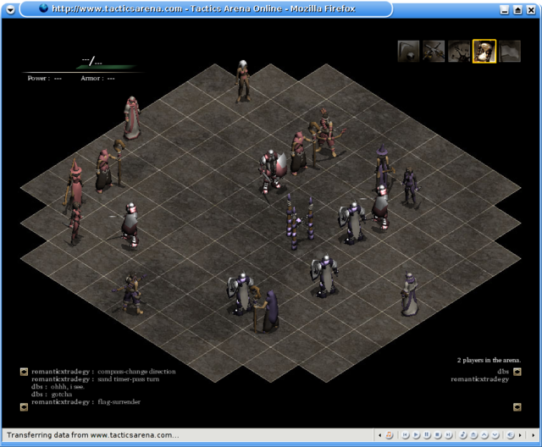  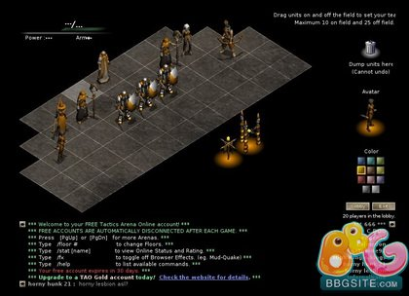

Final Fantasy Tactics

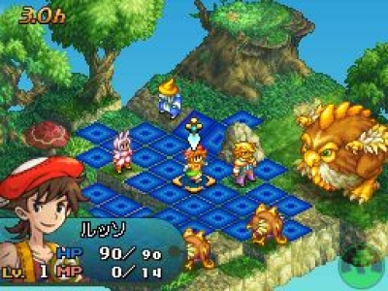  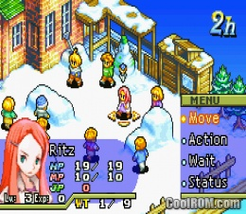

Characters (Units/Pieces)

[Unit Spreadsheet](https://docs.google.com/a/uci.edu/spreadsheets/d/1aTu4rTUQYx6VsWrD9ubFAJOJuLUy1NCjey2VQVlH4gE/edit#gid=0)